CSS Exercise

# The objective

The idea of this exercise is that you learn how to give basic style for your web page like color, borders, margins, padding etc. You use the most common and most used CSS selectors and properties in this exercise so you get hands on to it.

# Exercise

1. Use the mystyle.css file to define the styles in your web page
2. Think what colors you want to use in your web page.
3. Think what kind of selectors to use. At least use element, id and class selectors.
4. When you are ready test your CSS with validator: <http://www.css-validator.org/>

Important here is that you FOCUS on doing this exercise, search information with google or trainer -> Learn how to use the resources that are available. Use your imagination!!

Here is mine solution, note that I have set the background style for <body> to be black…

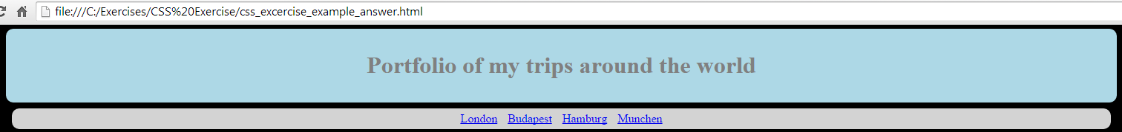

London <section>

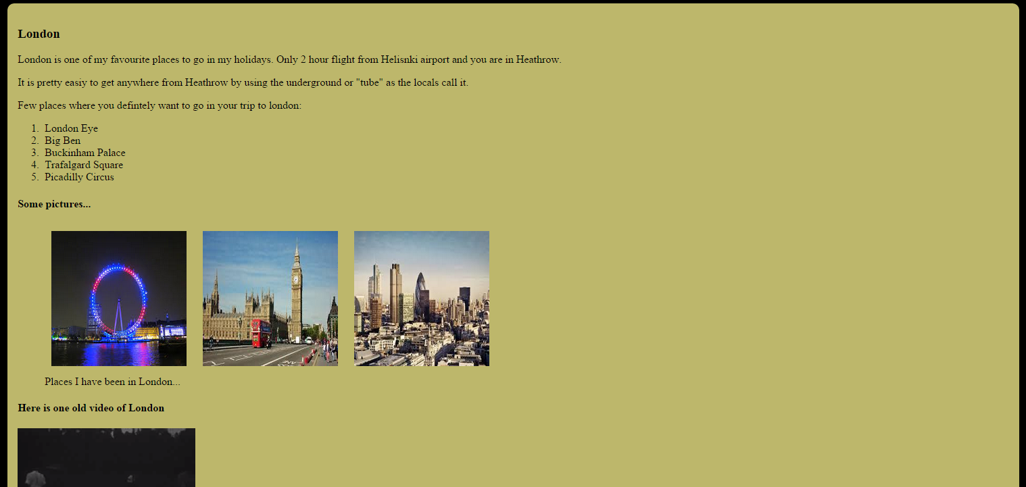

Budapest <section>

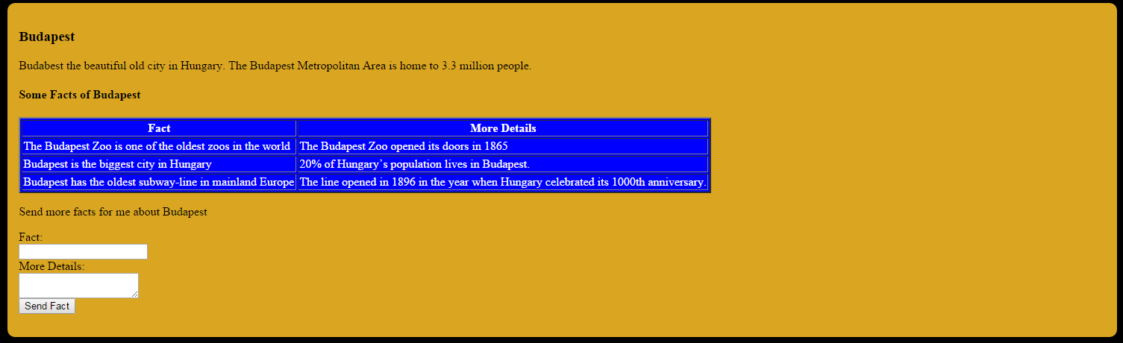

And the footer

